1.Build an area chart to display the sale trends of 2 product types - tea and coffee.
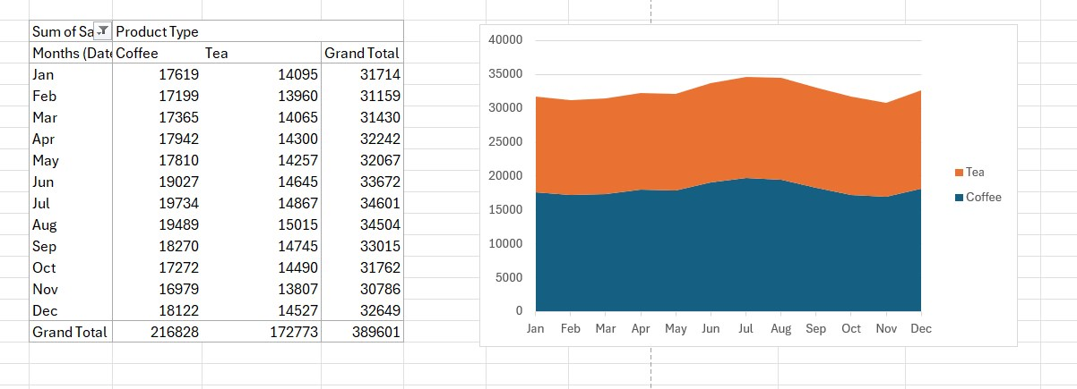

2. Build a pie chart to display the total sales distribution across all the four product types.
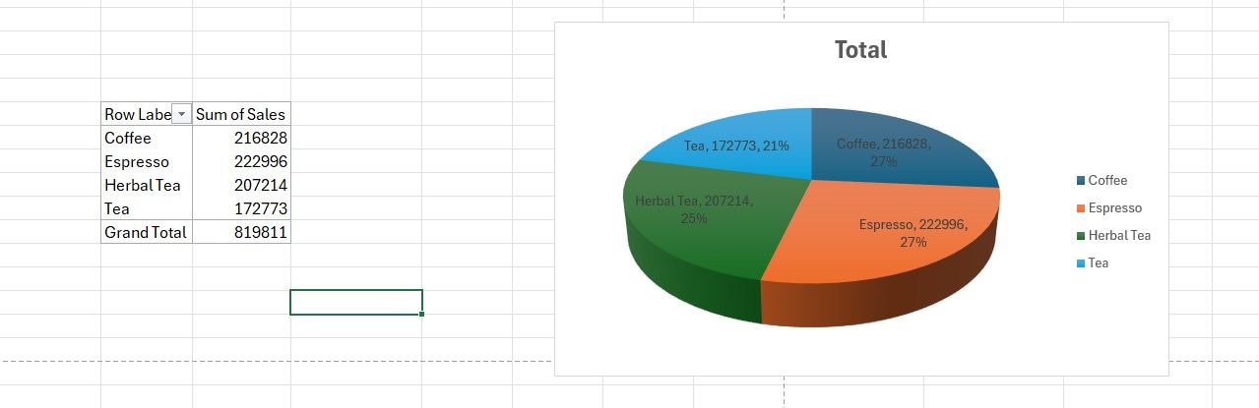

3.Provide a comparative chart of tea sales between the states.

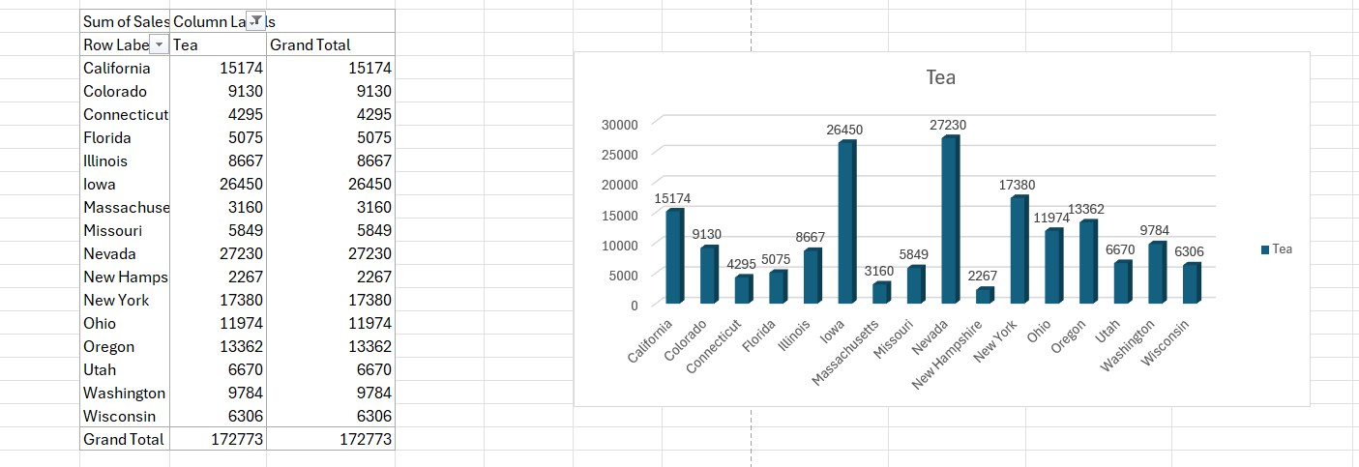

4.Provide a comparative chart of coffee sales between the states.
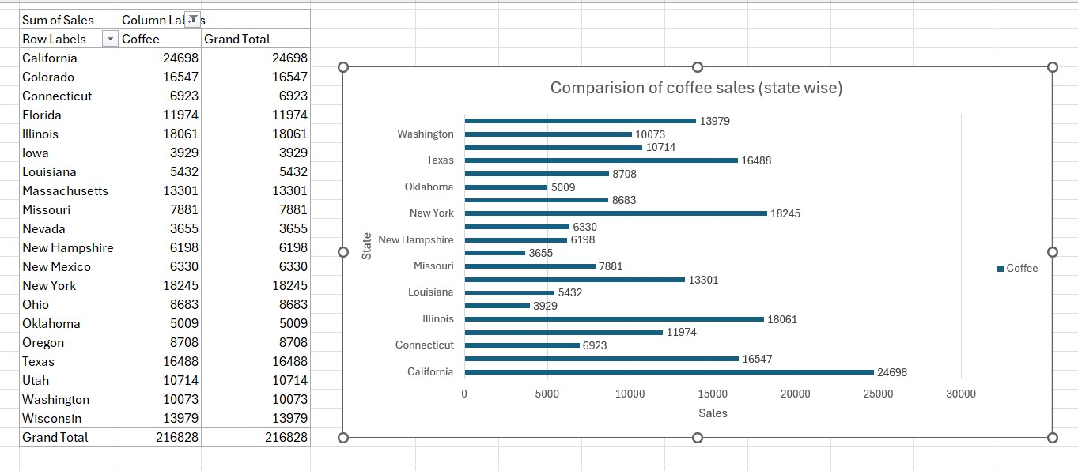

5.Identify the states with effective marketing campaigns and the states which need to revise their marketing strategies. (Note: Marketing effectiveness can be calculated by sum(profit)/sum(marketing)).

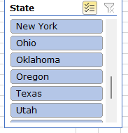

6. Build a scatterplot to show the correlation (if any) between sales and marketing expenses. Are you able to identify any changes over the years? (Note: Add a slicer to show the correlation between marketing and sales expenses based on the dates.)

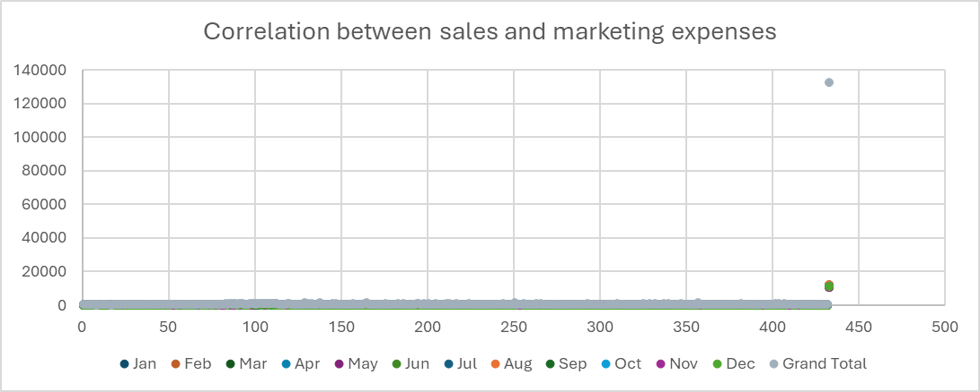

7. Create a slicer based on the product types. (Note: For the scatterplot created for the previous question, add a slicer for product types as well.)
